

**Bluetooth Low Energy Android Application**

16th October 2017 – Software version 1.00

1. **General Information**

This document is intended to describe the functionality of the android application that will be used to communicate with the NINA-B112 Bluetooth low energy modules.

Version 1 is only done to show the most common functionality such as

* Query Logger
* Program Parameters
* Start Logger
* Tag Logger
* Stop Logger
* Read Logger
* Re-Use Logger

1. **Application Activities**

This is the first page the application starts on. The available Bluetooth low energy devices can be found by pressing the SCAN button on the top right corner.

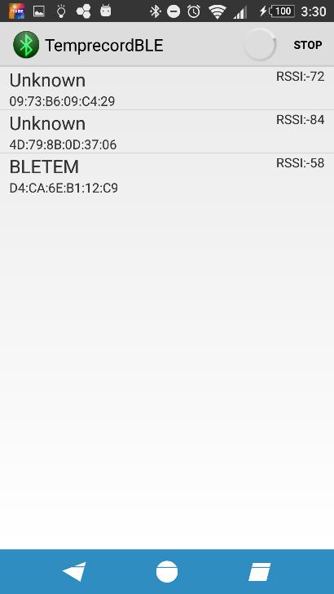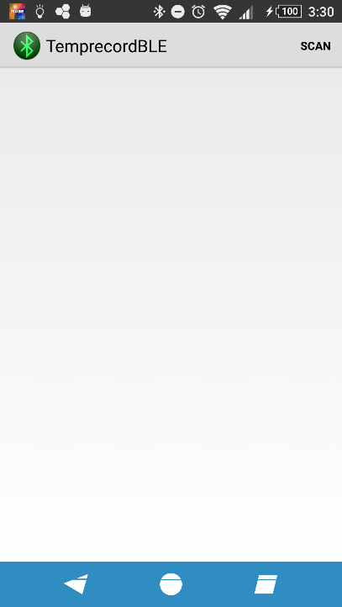

Once the button is pressed it displays a listview of the available BLE devices around with the RSSI – signal strength.

One of these devices is chosen to communicate with. The application is specifically written to communicate with NINA-B112 BLE modules. Connecting a different module will show an error.

Once a NINA BLE module is selected it will go into the third page

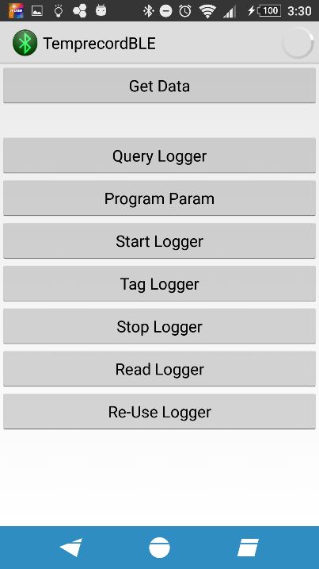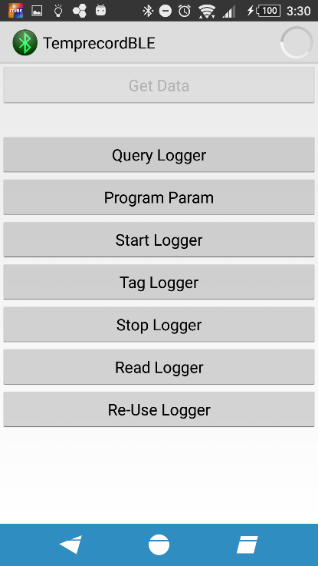The third page shows the available options. The “Get Data” button will become available to press ones the serial service is discovered. After This is pressed the application is ready to communicate with the module over BLE.

1. **Functionality**

**Query Logger**

Sends a byte array consisting of {0x00, 0x55, 0x01, 0x02, 0x0D} over BLE

**Program Parameters**

Sends a byte array consisting of {0x00, 0x55, 0x03, 0x__, 0x__, 0x0D} over BLE

**Start Logger**

Sends a byte array consisting of {0x00, 0x55, 0x01, 0x02, 0x0D} over BLE

**Tag Logger**

Sends a byte array consisting of {0x00, 0x55, 0x01, 0x02, 0x0D} over BLE

**Stop Logger**

Sends a byte array consisting of {0x00, 0x55, 0x01, 0x02, 0x0D} over BLE

**Read Logger**

Sends a byte array consisting of {0x00, 0x55, 0x01, 0x02, 0x0D} over BLE

**Re-Use Logger**

Sends a byte array consisting of {0x00, 0x55, 0x01, 0x02, 0x0D} over BLE

1. **Future work**

* Get all the basic buttons working
* Application can receive the return status from the commands sent to the module
* Better graphics user interface with functionality easily accessible to the end user
* Graphing functionality to show the data gathered over time
* Can program the name of the module from the application